**Technical Documentation of Creative Writing Generator**

**Overview of the project**

* We chose a project of **Creative Writing Generator** our project is mainly designed to Aid writers and creators also beginners in doing research by generating old stories to assist them knowing how the setting of the story started and knowing more of the characters. The generator was designed with code approach with languages such as Html, Java and CSS style to enhance its functional ability.

**Project Scope**

* The development and improvement of the frontend structure, which includes HTML, CSS, and JavaScript components, is the main focus of this project's scope.
* Creating a responsive and user-friendly interface is part of this step, which guarantees the best possible performance and usability across a range of devices and browsers.
* The project will not only construct the main interface but also delineate possible points of integration with back ends for AI formation.
* In addition to being capable of operating independently, this forward-thinking strategy makes sure the frontend is ready for increasingly sophisticated features including AI-generated content or interactions.

**UI Layout and Element Mapping**

* **Header:**  
  Logo: Fire.jpg  
    
  Template selector: #templateSelector
* **Form:**  
  Inputs: Genre, Title, Author, Characters, Storyline, Message, DateGenerate button: #generateBtn
* **Result:**  
  Output: #resultBox  
    
  Download PDF: #downloadBtn
* **Footer:**  
  Static copyright

**Template Selector**

* Main purpose is of Template Selector is to allow the end-user or stakeholder to have multiple choices of which type of templates is suitable for them, it place holds from Template1 to Template5 meaning they have 5 different choices to select from.

**PDF Download Logic**

* We implemented download button with using JavaScript to capture the generated content coming from the result box then transforms into styled PDF format.

**Prompt Engineering Methodology**

* **Objective** - to employ artificial intelligence (AI) to dynamically produce excellent, customized creative writing outputs depending on user inputs and chosen structural templates.

**User Interphase Layer**

* Genre {Horror, Rom-Com)
* Title
* Author
* Characters {Own choice}
* Storyline {Setting outline}
* The message {Theme}
* Template Selector {Gives scope of structure}

All these inputs play a role in prompt building blocks to build a structure for AI text generation

**Template Based Prompt Construction**

* Narrative Voice **(Who is telling the Story)**
* Story Structure **(How the story is built)**
* Tone VS Pacing **(How the story feels and how fast it moves)**
* Styling Elements **(Extra touches to make the story unique)**

**Final Results of the Creative Writing Generative AI**

* Gathers artistic components from the user
* Converts them to prompt formats driven by templates.
* Gets a finished prompt suited for the creation of stories by AI.
* Produces aesthetically pleasing output and supports PDF export.

**Clear Form With no results**

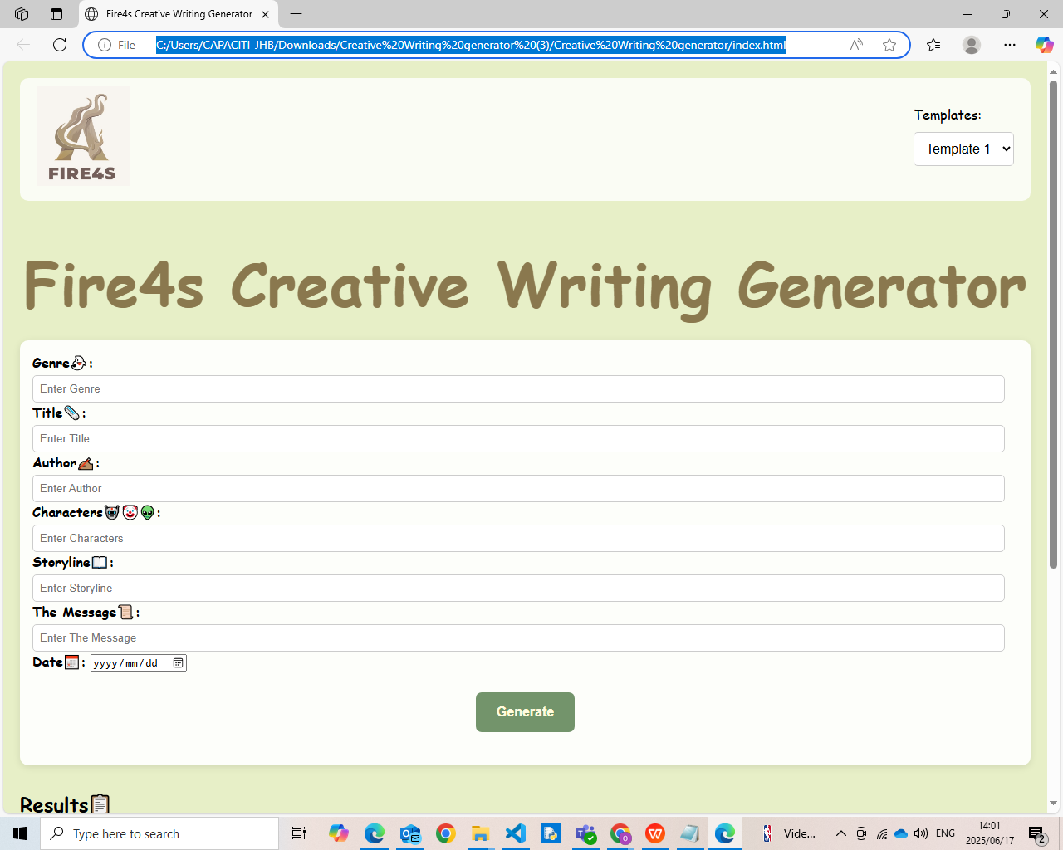

**Creative writing form with results with PDF export**

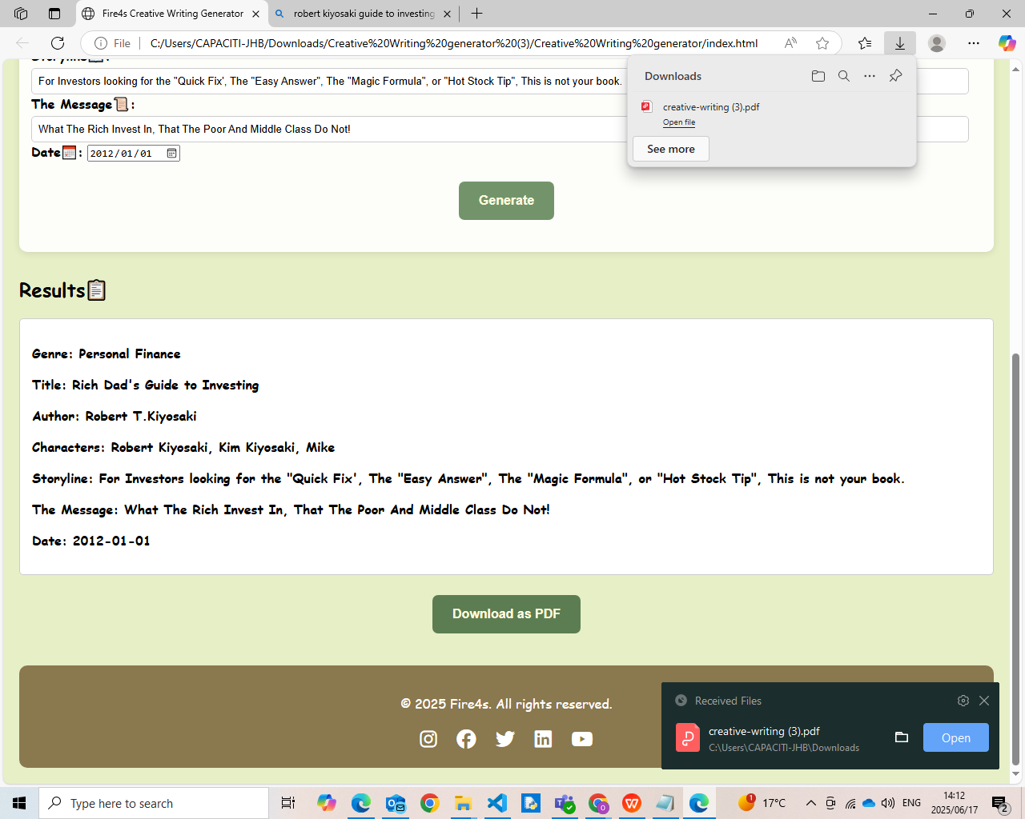

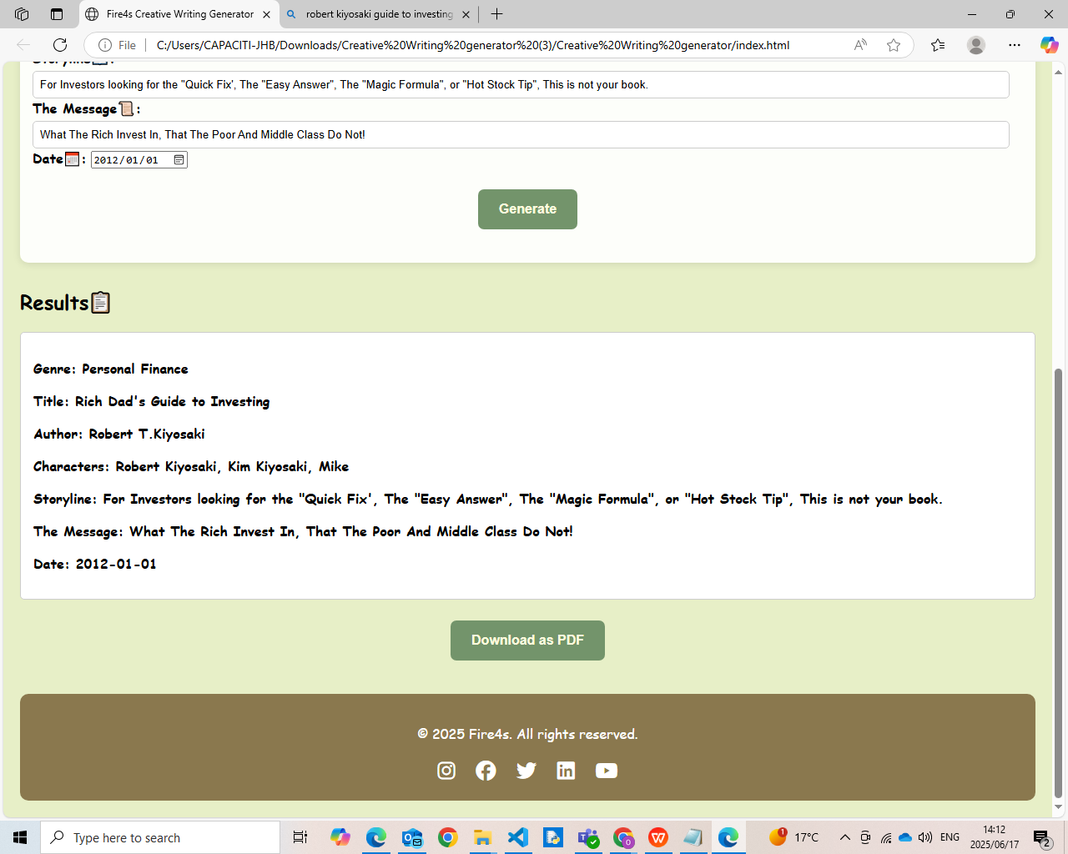

Reference

<https://cdnjs.cloudflare.com/ajax/libs/jspdf/2.5.1/jspdf.umd.min.js>

<https://cdnjs.cloudflare.com/ajax/libs/font-awesome/6.5.0/css/all.min.css>

<https://www.cloudflare.com/>

<https://www.cloudflare.com/searchresults/?q=API&language=English>